1. Task 1
   1. Generate a sine wave signal having amplitude 5 with a frequency of 1 Hz and a duration of 1 second using MATLAB.
   2. Multiply the sine wave signal by a ramp function to obtain a output like the figure below

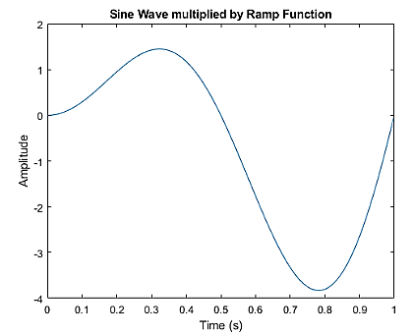

* 1. Condition the amplitude of the resulting signal from -2 to 2.
  2. Quantize the signal using a 3-bit analog-to-digital converter (ADC) with a sample and hold technique. You can use round function to generate the quantized signal

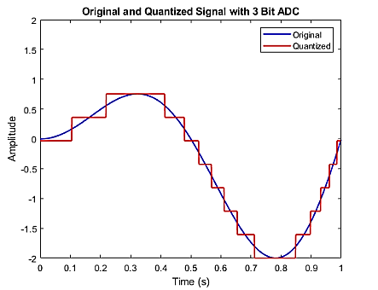

* 1. Find the Quantization error and plot the error for comparison

quantization_error = result - quantized_signal

* 1. Plot histogram for Quantization error
  2. Reconstruct the original signal using an ideal low-pass filter (sinc filter) with a cutoff frequency of 5 Hz implemented on Quantized signal
  3. Plot the original signal, reconstructed signal, and the difference between these two signals on the same graph.
  4. Analyze the effects of quantization on the reconstructed signal.

1. Task 2

How does changing the value of ADC bits from 3 to 4,5,6 effects the quantization error and the reconstructed signal. Support your observations with plots and graphs

1. Task 3

How does the cut off frequency of ideal low pass filter is task 1 effects the reconstructed signal. Support your observations with plots and graphs

1. Task 4

In Task 1 we have used round function to quantize the signal in step d . how does the following functions (round-off, floor & ceil) effects the output. Support your observations with plots and graphs

1. Task 5

Write MATLAB code to perform the following tasks:

* 1. Load an audio file
  2. Plot the audio signal for 1 second
  3. Define ADC parameters with 2 bits.
  4. Quantize the audio segment using a sample and hold technique.
  5. Plot the original audio segment and the quantized version for same time duration (1sec) .
  6. Play both the original and quantized audio segments.
  7. Design an ideal low-pass filter (sinc filter) for reconstruction with a cutoff frequency such that your audio frequency components are preserved .
  8. Normalize the sinc filter.
  9. Reconstruct the signal using the filter function.
  10. Plot the reconstructed signal, original audio segment and the quantized version for same time duration (1sec)
  11. Play the reconstructed signal.
  12. Plot the reconstructed signal m
  13. Write your observation for the quantized and reconstructed signal
  14. Change bit depth to 2,3,4 and then listen and take notes of your observations. Decide no. of bits for audio until quality stops improving